Lab 3: CPU Scheduling
In this lab you should use the CPU simulation program provided to gather data to complete copies of the table below. Read the “Instructions for using the CPU scheduling simulator” on Canvas before you begin.
Ask the CPU scheduling simulator to generate random data and use the snipping tool to copy the output to show the random data generated. You can re-run with new data at any stage, just make sure to show the new data at the relevant stage. Alternatively you can enter your own data as needed.
- For each algorithm simulation run:
  - Use the snipping tool to copy and paste the output into your document.
  - Indicate whether the algorithm is pre-emptive or non-pre-emptive.
  - Identify each time unit that a process switch occurs and fully explain why a switch happened at that time (e.g. because the previous process’s burst was complete or because the previous process was pre-empted – fully explain why).
  - For each process switch that occurs, fully explain why the relevant scheduling algorithm made the choice it did. (Identify the processes that were in the competition (i.e. in the ‘ready’ pool) at that time. Fully explain why the winner was chosen.)
  - Fill in a copy of the table provided below. Look at the example table to see how.
- SPN and SRT both allow starvation but the others do not. To investigate this load the default data (option 2 in the simulator menu) then run the SPN or SRT algorithms as normal and note when process p1 gets its first use of the CPU.
Then re-run the same algorithm using the facility to ‘add data on the fly’. At time 3 when asked if you want to add data say ‘y’ and add 10 new processes all arriving now (i.e. time 0) and looking for 1 unit of service.
Now note again when process p1 gets its first use of the CPU.
Are the new processes always able to jump the queue? Why is that?
What would happen if you continued to add new short processes at times 5,6,7, etc.?
Try to add new processes at about the same time during the run of the other algorithms (FCFS [at time 3], RR [at time 4], HRRN [at time 3]) to see if there is a difference. Record your observations. Are the new processes always able to jump the queue? Why is that? What would happen if you continued to add new short processes at times 5,6,7, etc.?
EXAMPLE
Process | Arrival Time | Service burst | Wait time | Turn-around time | NTT ratio (show fractions)
p0 | 0 | 2 | 0 | 0+2=2 | 2/2
p1 | 1 | 6 | 1 | 1+6=7 | 7/6
p2 | 3 | 3 | 5 | 5+3=8 | 8/3
p3 | 4 | 1 | 7 | 7+1=8 | 8/1
p4 | 6 | 7 | 6 | 6+7=13 | 13/7

Algorithm
Process | Arrival Time | Service burst | Wait time | Turn-around time | NTT ratio (show fractions)
p0
p1
p2
p3
p4

1. First come First serve
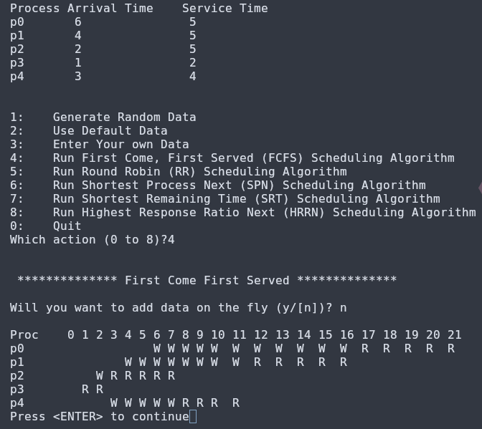
a.

b. First come first serve is a non pre-emptive algorithm, once a program begins it will keep running until it has reached its end

c/d. At proc 2 a process switch occurs to allow p2 to run – As the previous process, p3 has finished running.
At proc 7 a process switch occurs to start p4 – As the previous process p2 has finished running.
At proc 12 a process switch occurs to start p1 – As the previous process p4 has finished running
At proc 16 a process switch occurs to start p0 – As the previous process p1 has finished running.

e.

Algorithm
Process | Arrival Time | Service burst | Wait time | Turn-around time | NTT ratio (show fractions)
p0 | 6 | 5 | 11 | 16 | 16/5=2.3
p1 | 4 | 5 | 8 | 13 | 13/5=2.6
p2 | 2 | 5 | 1 | 6 | 6/5=1.2
p3 | 1 | 2 | 0 | 2 | 2/2=1
p4 | 3 | 4 | 5 | 9 | 9/4=2.25

2.Round Robin
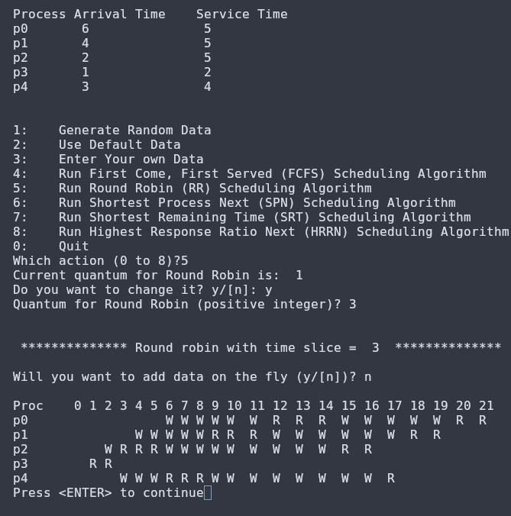

a.

b. Pre-emptive as once it has hit its quantum of 3, it will interrupt this process and move onto the next process
c/d.
A process switch occurs at proc2 when p3 has finished and can move onto p2
A process switch occurs at Proc5 as p2 has reached its first quantum of 3 and must move on to p4
A process switch occurs at proc 8 as p4 has reached the quantum of 3 and must give the cpu to p1
A process switch occurs at proc11 as p1 has reached the quantum of 3 and must hand over the cpu to p0
A process switch occurs at proc14 as p0 has reached the quantum of 3 and must give cpu access to p2
P2 meets its service time at proc16 and then gives the cpu to p4
p4 finishes its run time at proc17 and then gives the cpu to p1
p1 finishes at proc19 and gives the cpu to p0 for the last switch

e.

Algorithm
Process | Arrival Time | Service burst | Wait time | Turn-around time | NTT ratio (show fractions)
p0 | 6 | 5 | 10 | 15 | 15/5=3
p1 | 4 | 5 | 11 | 16 | 16/5=3.2
p2 | 2 | 5 | 10 | 15 | 15/5=3
p3 | 1 | 2 | 0 | 2 | 2/2=1
p4 | 3 | 4 | 11 | 15 | 15/4=3.75

3. Shortest Process Next

a.
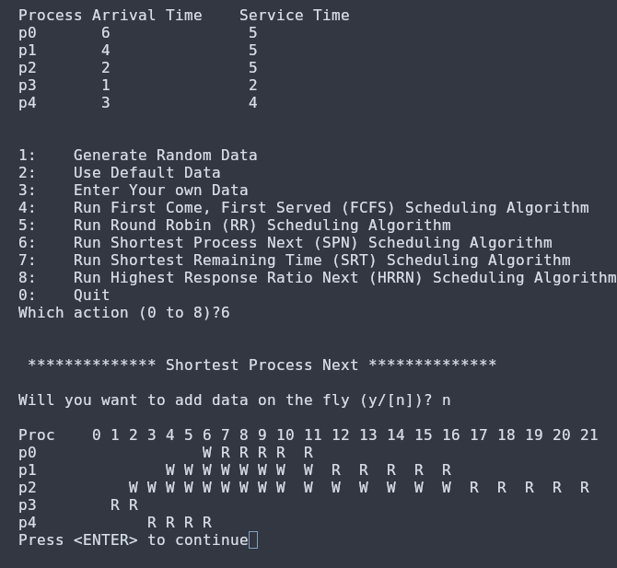
b. This a non pre-emptive algorithm as once the shortest program begins it will continue running until it has reached its service time.
c/d. At proc2 a process switch occurs from p3 to p4 as p3 has reached its service time and there are no other processes in the waiting state so it is by default the shortest process
At proc 7 a process switch occurs from p4 to p0 as all the other processes have a waiting time of 5 so it is technically the shortest process next
At proc 7 a process switch occurs from p0 to p1 as all the other processes have a waiting time of 5 so it is technically the shortest process next
At proc 7 a process switch occurs from p1 to p2 as all the other processes have a waiting time of 5 so it is technically the shortest process next

e.

Algorithm
Process | Arrival Time | Service burst | Wait time | Turn-around time | NTT ratio (show fractions)
p0 | 6 | 5 | 1 | 6 | 6/5=1.2
p1 | 4 | 5 | 7 | 12 | 12/5=2.4
p2 | 2 | 5 | 8 | 13 | 13/5=2.6
p3 | 1 | 2 | 0 | 2 | 2/2=1
p4 | 3 | 4 | 0 | 4 | 4/4=1

Shortest remaining Time
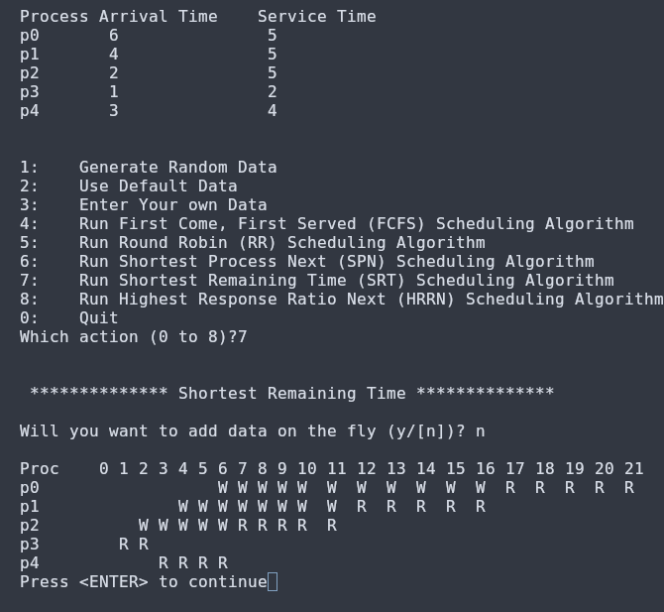

a.

b. This is a non pre-emptive algorithm as once the process with the shortest remaining service time begins, it will not end until it has fully completed
c/d. At proc2 a proccess switch occurs from p3 to p4 as p4 is the process with the shortest remaining time of 4 compared to p2 with 5 services left.
At proc7 a process switch occurs to p2 from p4 as the next shortest remaining time is p2 and p4 had reached its service time.
At proc12 a process switch occurs from p2 to p1 as p2 has finished its service time and p1 and p0 have the same remaining service time.
At proc17 a process switch occurs from p1 to p0 as p1 has finished its service time.
e.

Algorithm
Process | Arrival Time | Service burst | Wait time | Turn-around time | NTT ratio (show fractions)
p0 | 6 | 5 | 10 | 15 | 15/5=3
p1 | 4 | 5 | 7 | 12 | 12/5
p2 | 2 | 5 | 4 | 9 | 9/5
p3 | 1 | 2 | 0 | 2 | 1
p4 | 3 | 4 | 0 | 4 | 1

Highest Response Ratio

a.
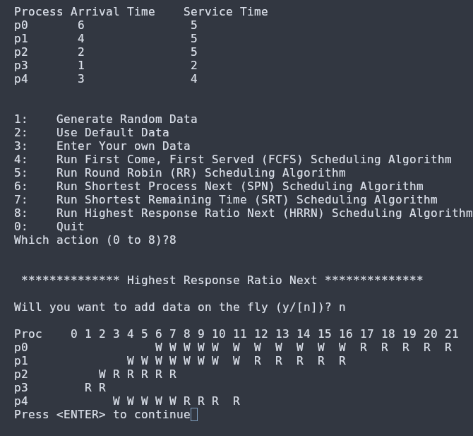

b. This is a non-pre-emptive scheduling algorithm meaning that once a process starts it will continue until reaches the end of its service time.
c/d.
At proc2 there is a process switch to p2 despite p4 having less services to complete, the ratio is just better here.
At proc7 there is a process swithc to p4 as it has a better response ratio than p1 or p0.
At proc11 there is a switch to p1 as it has less wait time than p0 yet having the same remaining service time.
At proc16 there is a process switch to p0 as p1 reached its final service time.

e.

Algorithm
Process | Arrival Time | Service burst | Wait time | Turn-around time | NTT ratio (show fractions)
p0 | 6 | 5 | 10 | 15 | 3
p1 | 4 | 5 | 7 | 12 | 12/5
p2 | 2 | 5 | 1 | 6 | 6/5
p3 | 1 | 2 | 0 | 2 | 1
p4 | 3 | 4 | 5 | 9 | 9/4

2.

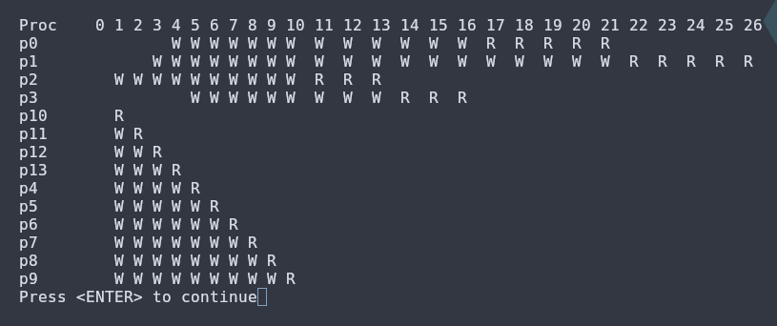

As you can see above with the extra process, we see major starvation in shortest process next through adding processes of service time 1. Every original process’ wait time is majorly increased. This is a clear demonstration of starvation where in which a process like p2 had started much before a lot of these processes but becuase the newer proceses are shorter, they get higher priority and are seemingly able to “jump” the queue that had originally formed.

